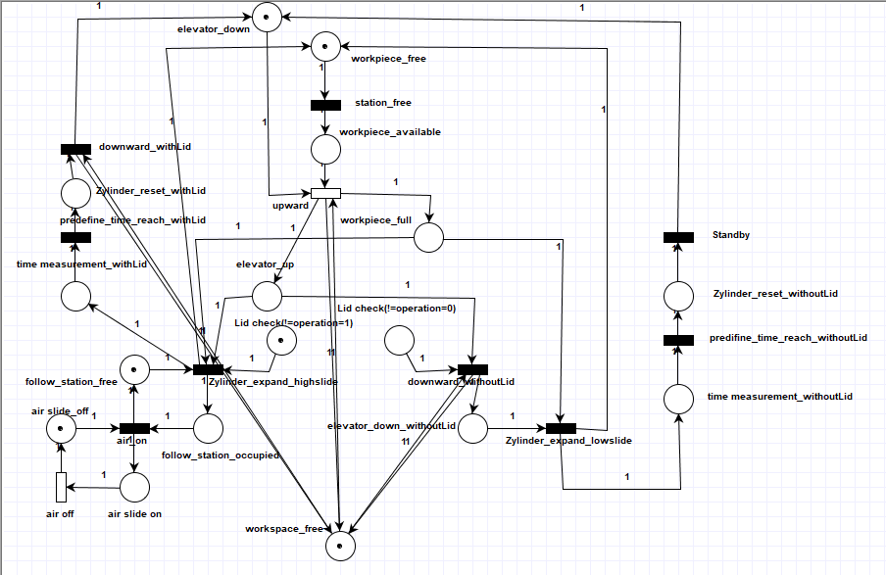

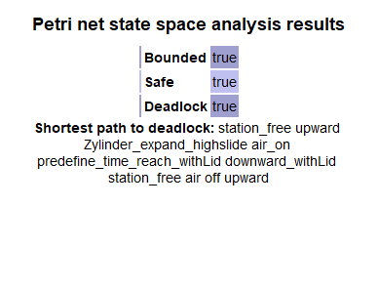**Characteristics analysis**: By using the analysis tool in PIPE, it can be seen that the petri net of Festo system that I designed by myself has deadlock.

The reason for the deadlock is obvious: the two states in the middle part of the figure (Lid check(!=operation=0/1)) are pre-assigned and can only be executed once, what makes the entire petri net weak alive.

The reason for this design is that, in the current simulation, the actual properties of the real workpieces (black/non-black, height) are not yet known, so i decided to introduce ahypothetical measurement results (Lid check(!=operation=0 or 1)) in these two states.

**Pros and cons of the Petrinet-Modeling**:

Pros: Compared with Code programming, Petrinet’s graphical design language can make the structure of the entire system more intuitive. After the model design is completed, people can also quickly analyze the defects of the current design through the analysis tool in PIPE. By using the „Animation Model“ the understanding of the entire simulation process is also much faster and more interesting than reading the codes.

Cons: When there are too many components in the entire system, especially when the relationship between the components is particularly complicated, there will be many arrows overlapping each other, which may make the structure of the entire system no longer intuitive. In addition, if there are many subsystems or components with the same function in the system, they should be able to be combined to make the entire structure more concise.